CANADIAN JEWISH TV IS COMING TO OMNI TV
A TV advertising opportunity to reach a National Jewish Audience

Why the show is important

Toronto's Jewish flavour is so strong, that it deserves a show of its own - broadcast across
Canada. Don't you think? That is how we the creators of CJTV feel.

So we have created a weekly interview program to showcase the best Jewish-style restaurants, local businesses, entrepreneurs and pioneers in the GTA. It’s a Toronto focused show, with arms that reach out to all Jewish communities across Canada.

A show that will get up close with the Jewish moguls and icons, to speak about their Jewish identity and their journey to fame and fortune.

A show that will evoke all of the old-world splendour of Eastern Europe, where so many of our loved ones endured hard lives to eventually come here and give us better ones.

A showcase for the amazing Jewish organizations that work around the clock to preserve cherished Jewish values and help those in need

A show that tips its hat to the incredible diversity of our Toronto Jewish community.

A show that will educate the masses on the facts about Jewish culture, history and identity and dispel the horrible misinformation that breeds Anti-Semitism.

About the Host

Ieden Wall is a best-selling poet, journalist, host and TV producer.

At 19 years-old Wall was hired on Rogers Cable to host his own regular segment called
“Off the Wall”. He won 2 Ontario Cable Awards for his mix of humour and human interest.

In 2010 Wall received a special Humanity in Humour Award from Yuk Yuk’s Owner Mark Breslin, for his WebTV series called The Dream Chaser.

Wall produced a 1-hour TV Special based on his reality/comedy series, which featured Mayor David Miller, who offered commentary throughout the show.

Wall's first book of poetry called The Wisdom of Wall sold over 30,000 copies in its first printing and has been the recipient of numerous awards.

Wall produced a collection of poetry films from his book which aired on TV, in Canada, Australia and the UK.

Wall was a regular contributor to the Canadian Jewish News.

Wall hosted Jewish Review TV for 3 years, for Index Media. On the show, he interviewed some of the most accomplished names in the Jewish world.

Wall's tribute film called My Bubby & Me was screened at over 20 synagogues across Canada.

A lover of Kabbalah, Wall always makes time for learning and teaching alike.

His ability to disarm his guests and get them to open up, makes him a coveted host and interviewer -- on both TV and radio.

The former Program Director at CFRB 1010 Steve Kowch said, "Wall has an uncanny knack to get people to come on his show and reveal deep secrets and personal details. He is one of
our country's great conversationalists"

Click or copy and paste this link below to view Wall on TV
https://youtu.be/HEiwRO7q8I8

The projected line-up of guests coming on the first season of Lox, Stock and Radio:

- Jewish Film Producer Robert Lantos
- Jewish Media Mogul Paul Godfrey
- Jewish Theatre Mogul David Mirvish
- Jewisih Comedy Mogul Mark Breslin
- Jewish News anchor Steve Paikin
- Jewish comedian and TV star Howie Mandel
- Jewish Film and TV star Eugene Levy
- Jewish Sports Mogul Larry Tanenbaum
- Jewish Filmmaker David Cronenberg
- Jewish superstar sportscaster Dan Shulman
- Jewish singer/songwriter Steven Page
- Jewish actress/singer Pink

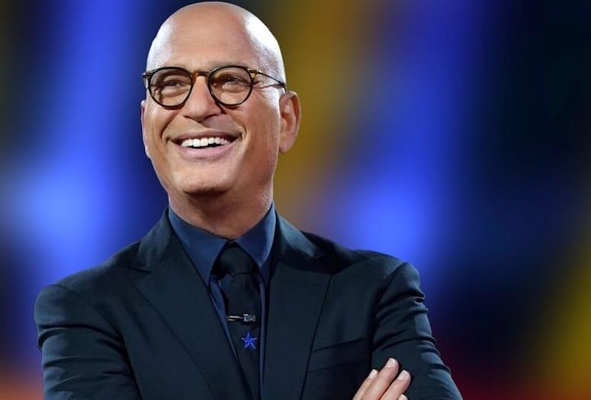
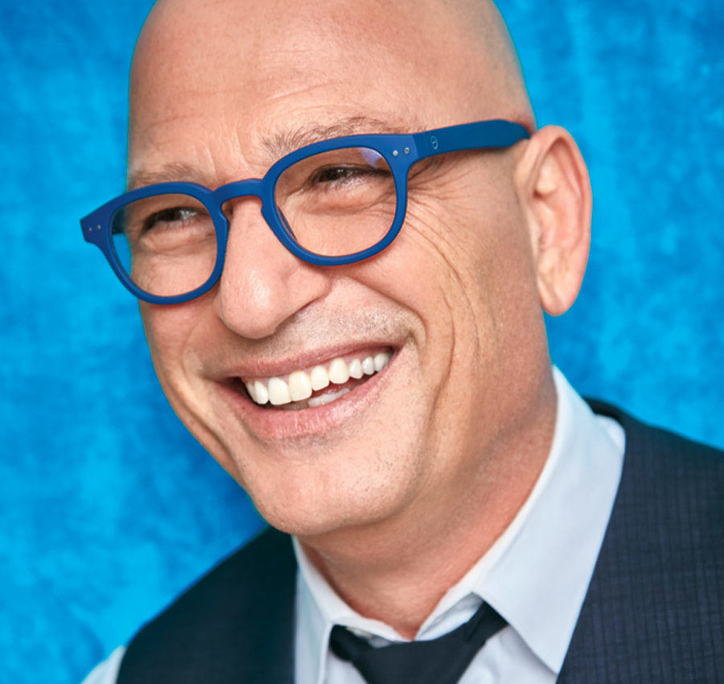

Sponsorship Opportunities

Dear Sponsors,

We are actively seeking sponsors to strategically align with for our fall season.
And as a sponsor, here is what you will get back in return:

--The satisfaction of supporting the first Jewish TV show on mainstream national TV.

--Primary sponsors will have an opportunity to be interviewed on
1 of the 13 first episodes. We will let you guide the content to suit your needs.

--Full production of your own 30/60 second HD TV commercial to run on OMNI TV (52 airings) and our official website, which you will own and be able to run on social media, on your own website, or any other digital platform

-Your commercial posted on our CJTV Visual Directory for 6 months

--Your own banner on our official website with a link to your website (if you wish)

--Exposure to the Jewish audience of Toronto and southern Ontario (12 million homes) and across the country -- a demographic recognized as a highly desirable, high-income bracket for advertisers

--First option to come on board for next season (you will have the option to come
on board again, whereas other sponsors might face possible refusal )

--Primary sponsors will be placed on 20,000 T-shirts, ball-caps, mugs, calendars and all first-run merchandising

Primary Sponsorship is available (your own 4 minute interview & 60 sec commercial )
Just $1K per episode

Secondary Sponsorship is available (30 second commercial)
Just $500.00 per episode

